Basavarajeswari group of institutions

BALLARI INSTITUTE OF TECHNOLOGY & MANAGEMENT

NACC Accredited Institution*


(Recognized by Govt. of Karnataka, approved by AICTE, New Delhi & Affiliated to Visvesvaraya Technological University, Belagavi)
"JnanaGangotri" Campus, No.873/2, Ballari-Hospet Road, Allipur, Ballar1-583 104 (Karnataka) (India)
Ph: 08392 – 237100 / 237190, Fax: 08392 – 237197

DEPARTMENT OF CSE(DATA SCIENCE)

A Dashboard Project Report On
“SALES DASHBOARD ANALYSIS”

A report submitted in partial fulfillment of the requirements for the

DATA VISUALIZATION WITH POWER BI

Submitted By

Name: A BRAMHAYYA ACHARI USN:3BR23CD001

Under the Guidance of Mr.Sundeep Sindhanoor
Asst. Professor
Dept of CSE (DATA SCIENCE),
BITM, Ballari



Visvesvaraya Technological University

Belagavi, Karnataka 2025-2026
BASAVARAJESWARI GROUP OF INSTITUTIONS

BALLARI INSTITUTE OF TECHNOLOGY & MANAGEMENT
NACC Accredited Institution*
(Recognized by Govt. of Karnataka, approved by AICTE, New Delhi & Affiliated to Visvesvaraya Technological University, Belagavi)
"JnanaGangotri" Campus, No.873/2, Ballari-Hospet Road, Allipur, Ballari-583 104 (Karnataka) (India)
Ph: 08392 – 237100 / 237190, Fax: 08392 – 237197




DEPARTMENT OF CSE (DATA SCIENCE)
CERTIFICATE
This is to certify that the open ended project report on DATA VISUALIZATION WITH POWER BI “SALES DASHBOARD ANALYSIS” has been successfully presented by A BRAMHAYYA ACHARI bearing USN3BR23CD001 student of semester B.E for the partial fulfillment of the requirements for the award of Bachelor Degree in CSE(DS) of the BALLARI INSTITUTE OF TECHNOLOGY& MANAGEMENT, BALLARI during the academic year 2025-2026.

Signature of guide Signature of HOD

Mr. Sundeep Sindhanoor Dr. Aradhana D

The satisfactions that accompany the successful completion of open ended mini project on “SALES DASHBOARD ANALYSIS” would be incomplete without the mention of people who made it possible, whose noble gesture, affection, guidance, encouragement and support crowned my efforts with success. It is our privilege to express our gratitude and respect to all those who inspired us in the completion of our mini-project. We are extremely grateful to our Guides Mr.Sundeep Sindhanoor for their noble gesture, support co-ordination and valuable suggestions given in completing the mini-project. We also thank Dr. Aradhana D, H.O.D. Department of CSE(DS), for his co-ordination and valuable suggestions given in completing the mini-project. We also thank the Principal, Management and non-teaching staff for their co-ordination and valuable suggestions given to us in completing the project.

Name | USN
A BRAMHAYYA ACHARI 3BR23CD001

Table of Contents

Ch No | Chapter Name | Page
1 | Introduction  1.1 Background  1.2 Scope | 1-2
2 | Data Description  2.1 Problem Statement  2.2 Objectives | 3
3 | System Requirements  3.1 Functional Requirements  3.2 Non-Functional Requirements  3.3 Hardware Requirements  3.4 Software Requirements | 4-5
4 | Methodology  4.1 Data Collection  4.2 Data Preparation (Power Query)  4.3 Dashboard Design | 6-7
5 | Dashboard Analysis  5.1 KPI Overview  5.2 Profit by Sub-Category  5.3 Quantity by Payment Mode  5.4 Geographical Distribution  5.5 Amount by Customer  5.6 Profit by Month | 8-10
6 | Key Findings & Insights  6.1 Sales Performance  6.2 Payment Trends  6.3 Regional Insights | 11
7 | Conclusion & Recommendations  7.1 Conclusion  7.2 Recommendations | 12

Chapter 1: Introduction

1.1 Background
This report presents a detailed analysis of the Sales Dashboard built using Microsoft Power BI. The dashboard provides a consolidated view of business performance metrics across product categories, customer segments, geographical regions, and payment modes for Q1. It enables business stakeholders to monitor KPIs, identify trends, and make data-driven decisions.

The Sales Dashboard visualizes data from transactional records covering categories including Furniture, Electronics, and Clothing. Key metrics such as total sales amount, profit, and quantity sold are aggregated and presented through interactive charts and maps.

1.2 Scope
The scope of this analysis covers the following dimensions of the sales data:
- Profit analysis across product sub-categories
- Sales quantity distribution by payment mode (COD, Credit Card, EMI, UPI, Debit Card)
- Geographical distribution of sales across Indian states
- Revenue contribution by individual customers
- Monthly profit trend analysis from January to March (Q1)
- Category-wise quantity and amount breakdown

The analysis is limited to Q1 data and focuses on the Furniture category, which represents 99.5% of total sales by amount (28K out of the total).

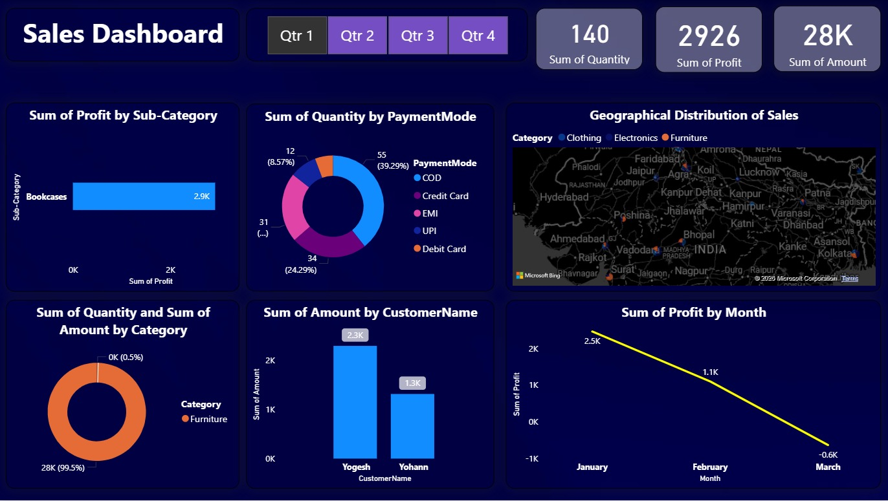
Chapter 2: Data Description

2.1 Problem Statement
Traditional sales tracking methods lack real-time visibility into performance trends, making it difficult for management to identify underperforming segments or capitalize on emerging opportunities. There is a need for a centralized, interactive dashboard that aggregates multi-dimensional sales data and presents actionable insights.

Specifically, the key challenges addressed are:
- Lack of consolidated profit tracking across product sub-categories
- Insufficient understanding of customer payment preferences impacting cash flow planning
- Limited geographic insight into where sales are concentrated across India
- No systematic month-over-month profit trend monitoring for Q1

2.2 Objectives
The primary objectives of this Sales Dashboard Analysis are:
- To provide a real-time overview of total sales KPIs — Quantity (140), Profit (2,926), and Amount (28K)
- To identify which product sub-categories contribute most to profit (Bookcases: 2.9K)
- To analyze payment mode preferences among customers
- To visualize the geographic spread of sales across India
- To track monthly profit trends and identify any declining performance
- To highlight top-performing customers by revenue contribution

Chapter 3: System Requirements

3.1 Functional Requirements
The Sales Dashboard must fulfill the following functional requirements:
- Display KPI cards for Sum of Quantity, Sum of Profit, and Sum of Amount
- Provide quarterly filtering capability (Q1, Q2, Q3, Q4)
- Render a horizontal bar chart for Profit by Sub-Category
- Display a donut chart for Quantity distribution by Payment Mode
- Show a Bing Maps visual for Geographical Distribution of Sales by Category
- Present a bar chart for Amount by Customer Name
- Display a line chart for Sum of Profit by Month
- Render a donut chart for Quantity and Amount by Category

3.2 Non-Functional Requirements
- Performance: Dashboard should load within 3 seconds on standard hardware
- Usability: Interactive slicers for quarter-based filtering
- Reliability: Data should refresh from source with 99.9% accuracy
- Scalability: Should support additional quarters and categories without redesign
- Accessibility: Color-coded visuals with clear labels for readability

3.3 Hardware Requirements
Visual / Metric | Insight / Observation
Processor | Intel Core i5 (8th Gen) or equivalent — minimum for Power BI Desktop
RAM | 8 GB minimum; 16 GB recommended for large datasets
Storage | 512 MB free disk space for Power BI Desktop installation
Display | 1280 x 800 resolution minimum; Full HD (1920x1080) recommended
Internet | Required for Bing Maps geographical visual and Power BI Service publishing

3.4 Software Requirements
Visual / Metric | Insight / Observation
BI Tool | Microsoft Power BI Desktop (latest version)
Data Source | Microsoft Excel / CSV / SQL Server
Operating System | Windows 10 / Windows 11 (64-bit)
Map Service | Microsoft Bing Maps (integrated in Power BI)
Browser (Service) | Microsoft Edge / Google Chrome for Power BI Service

Chapter 4: Methodology

4.1 Data Collection
The sales data was collected from the organization's transactional database covering Q1 (January to March). The dataset contains individual sales records with the following fields:
- Order ID and Order Date
- Customer Name (e.g., Yogesh, Yohann)
- Product Category (Furniture, Electronics, Clothing) and Sub-Category (Bookcases, etc.)
- Quantity, Amount (Revenue), and Profit per transaction
- Payment Mode: COD, Credit Card, EMI, UPI, Debit Card
- State/City for geographical mapping across India

The total dataset for Q1 encompasses 140 units sold across multiple transactions with a total revenue of 28K and net profit of 2,926.

4.2 Data Preparation (Power Query)
Data preparation was performed using Power Query Editor in Power BI Desktop. The following transformations were applied:
- Data type validation: Ensuring numeric columns (Profit, Amount, Quantity) are correctly typed
- Date parsing: Extracting Month name from Order Date for the monthly trend chart
- Category normalization: Standardizing product category and sub-category names
- Null value handling: Removing or imputing records with missing profit or amount values
- Filtering: Applying quarter-based filters using a calculated Quarter column

4.3 Dashboard Design
The dashboard was designed in Power BI Desktop with a dark navy blue theme (#1A2A4A background) for visual contrast. Each visual was assigned a specific region of the canvas to maximize information density. Slicers for quarterly filtering were placed at the top, and KPI cards were positioned prominently for at-a-glance performance review.

Chapter 5: Dashboard Analysis

5.1 KPI Overview
Visual / Metric | Insight / Observation
Sum of Quantity | 140 units sold in Q1 across all product categories and customers
Sum of Profit | 2,926 — net profit after accounting for costs across all transactions
Sum of Amount | 28K (28,000) — total revenue generated from all sales in Q1

The KPI cards provide an immediate snapshot of business health. A profit of 2,926 on revenue of 28K implies a profit margin of approximately 10.4%, which is moderate and warrants attention to cost optimization.

5.2 Profit by Sub-Category
The horizontal bar chart shows Sub-Category on the Y-axis and Sum of Profit on the X-axis. The dashboard (filtered to Q1) displays:
- Bookcases: 2.9K — the dominant and only visible sub-category, indicating high concentration
This suggests that Bookcases within the Furniture category are the primary profit driver for the business in Q1. There is a need to diversify profit sources across other sub-categories.

5.3 Quantity by Payment Mode
The donut chart reveals how customers prefer to pay for their purchases:
Visual / Metric | Insight / Observation
COD (Cash on Delivery) | 55 orders — 39.29% — the most popular payment mode
Credit Card | Segment visible in purple — significant preference
EMI | Instalment-based payments — notable share
UPI | 34 orders — 24.29% — strong digital payment adoption
Debit Card | 12 orders — 8.57% — lower preference
Other / Mixed | 31 orders — remaining segment (~...)

5.4 Geographical Distribution of Sales
The Bing Maps visual plots sales data across Indian states, with color-coded dots representing three categories:
- Blue dots — Clothing category sales
- Grey/White dots — Electronics category sales
- Orange dots — Furniture category sales

Key states with visible sales concentration include Rajasthan, Madhya Pradesh, Uttar Pradesh, and Maharashtra. The map shows that sales are distributed across central and northern India, with notable activity around major cities like Bhopal, Jaipur, Kanpur, and Nagpur.

5.5 Amount by Customer Name
The bar chart highlights top customers by total purchase amount:
Visual / Metric | Insight / Observation
Yogesh | 2.3K — highest revenue-generating customer in Q1
Yohann | 1.3K — second highest revenue contributor

These two customers together account for 3.6K out of 28K total, suggesting a highly distributed customer base. No single customer represents a dominant revenue dependency risk.

5.6 Profit by Month (Line Chart)
Visual / Metric | Insight / Observation
January | 2.5K — strongest profit month, peak performance in Q1
February | 1.1K — significant decline from January (-56%)
March | -0.6K — net loss, profit turned negative

The profit trend line shows a sharp and concerning downward trajectory across Q1. Starting at a high of 2.5K in January, the business experienced a 56% decline in February and slipped into a net loss of -0.6K in March. This needs immediate investigation into rising costs or declining sales volumes in March.

Chapter 6: Key Findings & Insights

6.1 Sales Performance
- Total Q1 revenue stands at 28K with a profit of 2,926, yielding an overall margin of ~10.4%
- Furniture dominates sales at 99.5% of total amount, with Bookcases as the primary sub-category
- Clothing and Electronics have negligible representation, showing a highly skewed product mix
- Profit trajectory is severely declining — moving from +2.5K in January to -0.6K in March

6.2 Payment Trends
- COD remains the dominant payment method at 39.29%, indicating customer preference for cash-based transactions
- UPI holds 24.29% share, reflecting growing digital payment adoption — an opportunity to incentivize UPI for faster payments
- Credit Card, EMI, and Debit Card account for the remaining ~36%, showing a healthy mix
- High COD ratio may impact cash flow due to return/non-delivery risks

6.3 Regional Insights
- Sales are concentrated across northern and central India — Rajasthan, UP, MP are key markets
- Major cities including Jaipur, Kanpur, Bhopal, and Nagpur show presence across categories
- Eastern and southern India regions appear underrepresented — a potential market expansion opportunity
- Electronics and Clothing categories have minimal geographic penetration compared to Furniture

Chapter 7: Conclusion & Recommendations

7.1 Conclusion
The Sales Dashboard for Q1 provides a clear picture of the business's performance across multiple dimensions. While the overall revenue of 28K is generated primarily through Furniture (Bookcases), the profit margin is thin at 10.4% and the month-on-month trend is deeply concerning, with a net loss in March. The geographic reach is primarily central and northern India, and COD remains the preferred payment mode.

The dashboard effectively enables stakeholders to monitor KPIs at a glance and drill down into category, customer, and payment-mode level details. However, the declining profit trend demands urgent strategic attention.

7.2 Recommendations
- Investigate March losses: Conduct root cause analysis on rising costs or revenue drops in March to prevent Q2 carryover of losses
- Diversify product portfolio: Actively promote Electronics and Clothing to reduce dependency on Furniture/Bookcases
- Incentivize UPI and Credit Card payments: Offer discounts or cashback to shift volume away from COD and improve cash flow predictability
- Geographic expansion: Target southern and eastern Indian markets (Bengaluru, Chennai, Kolkata) to unlock new revenue streams
- Customer retention: Develop loyalty programs for top customers like Yogesh and Yohann while acquiring new high-value customers
- Quarterly forecasting: Use the month-wise profit trend to build predictive models for Q2 planning

